UNIVERSITY RECORD MANAGEMENT SYSTEM

By

Group D

Gabriel Andino
Hiu Yan Li
Joyce Adikini
Kyle Wild

Submitted to

The University of Liverpool

MASTER-OF-SCIENCE -
INFORMATION SYSTEMS AND MANAGEMENT

Databases and Information Systems

Word Count: 1,472

20/07/2026

TABLE OF CONTENTS

Page

LIST OF TABLES 2

LIST OF FIGURES 3

Chapter 1. Introduction 4

Chapter 2. Database Design and Rationale 5

Chapter 3. Software Architecture 7

3.1 Dual back end via DB-API 2.0 7

Chapter 4. Query Implementation and Security 8

Chapter 5. Seed Data and Test Strategy 9

Chapter 6. User Acceptance Testing 10

Chapter 7. Known Limitations and Extension Path 11

Chapter 8. Conclusions 12

REFERENCES 13

Appendices 14

Appendix A User Acceptance Testing 14

A.1 Testing approach 14

A.2 GUI test cases (seven cases, all Pass) 14

A.3 CLI parity screenshots 22

A.4 Limitations and future improvements 23

A.5 UAT summary 23

Appendix B Extended Critical Analysis, Extension Path and Retrospective 24

B.1 Development narrative – MVP first 24

B.2 Extension path – from MVP to production 25

B.3 Extensibility priorities 25

B.4 Retrospective – what we would do differently 26

B.5 Alternatives considered and rejected 27

Appendix C Query Catalogue and SQL Evidence 28

C.1 Mapping each query to the brief 28

C.2 Cascading dropdown providers 28

C.3 Compressed SQL of each query (key clauses only) 29
LIST OF TABLES

Page
Table 1 – UAT Test Cases Summary 14
Table 2 - Query Catalogue Mapped to the Brief 28

LIST OF FIGURES

Page

Figure 1. Entity Relationship Diagram (ERD) of the University Record System 5
Figure 2. Query Interface (UAT-01) 15
Figure 3. Query Interface-2 (UAT-01) 15
Figure 4. Student enrolled in a specific course, taught by a specific lecturer 16
Figure 5. Safe fails when part of the query information is missing 16
Figure 6. Students with average results above 70% 17
Figure 7. Students not registered for any course in 2026 semester S2 18
Figure 8. Faculty advisor information for student with ID: 1007 19
Figure 9. Lecturer search by expertise area 20
Figure 10. Query builder interface 21
Figure 11. Custom query example 21
Figure 12. CLI – banner and numbered menu of nine queries 22
Figure 13. CLI – Query 6: advisor contact query (parity with Figure 8) 22
Figure 14. CLI – ‘?’ listing of enumerable parameter values (mirror of GUI dropdowns) 23

Introduction
Our task was to design and build a small university record management system: a database of students, lecturers, non-academic staff, courses, departments, programmes and research projects, with a way for users to query it. This report describes the system we built: a normalised relational schema of 20 tables with two Python interfaces (a Tkinter GUI and a command-line interface) that execute nine parameterised SQL queries, and the reasoning behind the design choices we made.
We have focused the report on the decisions that shaped the system: what we chose, what we rejected, and the costs we accepted. The longer supporting material is in five appendices: UAT evidence (A), extended critical reflection (B), the query catalogue (C), the schema reference (D), and deployment notes (E), each referenced in the relevant chapter.

Database Design and Rationale
Our database is a normalised relational schema of 20 tables, authored in MySQL Workbench (schema.sql), and mirrored for the demo backend (schema_sqlite.sql). It follows the relational model of Codd (1970), whose motivation: protecting users from disruptive changes in data representation, remains the core justification for the choices below. Any attribute that logically holds more than one value per entity – qualifications, expertise, publications, committees, research areas, prerequisites, materials, organisation memberships and project team members – we modelled as its own related table rather than as a repeating field. This keeps the schema in first normal form and makes those relationships directly queryable: averaging a student’s grades, counting a lecturer’s publications in a given year, or listing every course whose prerequisites include Introduction to Programming can all be expressed as single SQL statements rather than post-processing steps in Python. Two column-level choices deserve a note: grades stored as DECIMAL (5,2) NULL make SQL’s AVG() ignore in-progress courses automatically, and INT programme durations let "final year" be computed as year_of_study >= duration_years across every programme shape.
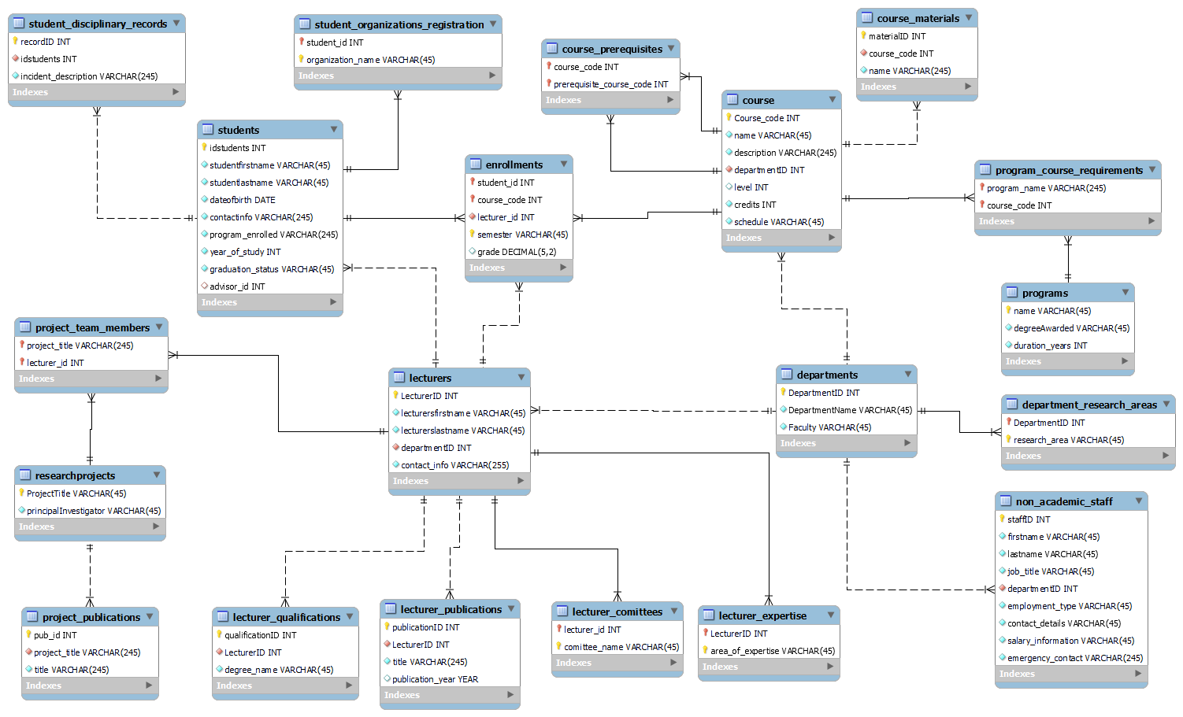
Figure 1. Entity Relationship Diagram (ERD) of the University Record System
The most instructive design tension we encountered was around foreign keys. During integration, our Database Designer’s normalisation replaced a broken VARCHAR-based department reference with a surrogate DepartmentID INT key referenced by lecturers, non_academic_staff and course, resolving a type mismatch that had precented joins altogether. However, programs still use its name VARCHAR as the primary key, which is referenced by student.program_enrolled and program_course_requirements.program_name. We accepted this inconsistency knowingly: introducing a surrogate program_id late in the build risked schema instability across two dialects and a large seed file, and the immutability of programme names during the assignment lifetime made the cost negligible. In production, a rename would cascade through two tables so that a surrogate key would be the correct long-term choice.

Software Architecture
We organised the application into three explicitly separated layers, mirroring the ANSI/SPARC three-schema model in which external, conceptual and internal levels are decoupled to enable independent change at each (Kishansing and Suthat, 2014). Our interfaces (main.py, gui.py) contain no SQL; our query engine (queries.py) contains no I/O and is directly unit-testable; our connection layer (db.py) is the only module aware of which DBMS is in use. Every query is declared once in queries.CATALOGUE, and both interfaces render whatever the catalogue declares, so they cannot silently drift apart. The value of this separation is empirical: we added the GUI, the cascading dropdowns, and the mid-project schema normalisation without modifying the other layers.
- Dual back end via DB-API 2.0
We write our SQL once using ? placeholder (the “qmark” style defined by the Python Database API Specification; Lemburg, 2001); a single line in db.py rewrites them to %s for mysql-connector. We rejected an ORM such as SQLAlchemy because the module assesses SQL competence: the SQL is our deliverable, and our GUI’s “Generated SQL” panel makes every executed query inspectable, which an ORM would hide. The cost – manual dialect management – is quarantined to two DDL files and one rewrite line, and would reverse at production scale with write-heavy transactions.

Query Implementation and Security
We implemented nine queries: eight predefined reports plus a "browse any table" option (queries.CATALOGUE), exceeding the brief's requirement of five. Each of our query functions returns (columns, rows) and is directly unit-testable. The full catalogue, with each query mapped to the brief and its key SQL clauses shown, is in Appendix C.
Our security posture is a two-layer injection defence that applies the primary defence recommended by OWASP (n.d.). We always pass values as bound parameters, never string-formatted, so a value such as x' OR '1'='1 returns zero rows rather than truthifying the WHERE clause. Identifiers: the table and column names used by our query builder, cannot be substituted by placeholders, so we restrict them to the whitelist in schema_meta.py, which the builder consults before generating any SQL. A column name such as nope; DROP TABLE students is rejected before any SQL is built.
Three further design choices: Tkinter over a web front end, a static schema whitelist over runtime introspection, and a consolidated CREATE script over a migration script, are defended in Appendix B.5, alongside the extended critical reflection.

Seed Data and Test Strategy
We engineered our seed data for falsifiability: every query has rows that must match and rows that must not. Our dummy_data.sql includes Chen Wei with an average of exactly 70.0 (excluded by the strict > 70 in query five), George Papadopoulos at 69.0 (just below), a graduated student (Jack Nowak), a deferred student (Ibrahim Diallo) and a failing grade (Julia Nowak's 32). Our programme durations span one to five years, so the final-year expression is exercised across all shapes.
Our unittest test suite covers every module in src/ against an in-memory SQLite copy of the real schema and data. We chose unittest over the more popular pytest to preserve a zero-dependency guarantee: our entire system, the application, both interfaces, and the test suite, runs on a bare Python installation.

User Acceptance Testing
Our full UAT evidence, seven test cases and ten annotated screenshots, is in Appendix A. We tested against ~400 rows of seed data using both the GUI and CLI; all seven cases passed. Two examples illustrate the value of the approach.
Safe query: an aggregate report validated by boundary rows. In UAT-03 (Appendix A, Figure 6), our "final-year students with an average grade above a threshold" query returned seven students at threshold = 70. Critically, Chen Wei (average 70.0) and George Papadopoulos (average 69.0) do not appear, confirming the strict > semantics and correct handling of the boundary; graduated students are also correctly excluded. Demonstrating an absent row proves more than showing a present one.
Failed query: a safe fail from missing input. In UAT-02 (Appendix A, Figure 5), leaving the Lecturer surname field blank raised a "Missing input" dialog and executed no SQL. Our GUI's validation loop checks each parameter before dispatching the runner: a deliberate choice to prevent incomplete queries reaching the database and returning misleading results.
The equivalent CLI outputs; menu, results table and ? parameter listing (Appendix A.4, Figures 12–14), confirm that our catalogue-driven architecture holds across both interfaces.

Known Limitations and Extension Path
The most significant modelling flaw we identified, and the strongest single item for critical reflection, is that teaching is currently derived from enrolments. We have no course_lecturers assignment table, so "who teaches course X" comes from enrollments.lecturer_id. A course with no students, therefore, has no lecturer in our system, an existence dependency we created by inferring a relationship instead of storing it. We discovered this during testing when the elective "Business Strategy" had no lecturer visible; we corrected the seed data and added a data-integrity test asserting "every course has a lecturer", but the correct long-term fix is a dedicated course_lecturers table.
Our application is also single-user by design, has no authentication, and is read-only. Because we hold personal data, contact details and disciplinary records, any multi-user deployment would fall within the scope of the General Data Protection Regulation, which requires that personal data be processed lawfully and securely, with appropriate access controls and integrity safeguards (European Parliament and Council of the European Union, 2016). Role-based access control would therefore be a prerequisite, not an optional extra. Our prioritised extension roadmap, from a shared departmental server through to cloud deployment, is documented in Appendix B.

Conclusions
We have delivered a normalised 20-table university record system with two Python interfaces, nine parameterised queries, dual SQLite/MySQL backends, comprehensive unit testing, and PEP-8-compliant code. Our layered architecture and zero-dependency test suite absorbed a mid-project schema normalisation without incident and, as Appendix B expands, give us a clear path from this MVP to a multi-user production deployment. Beyond simply delivering the system, working through it has taught us to defend our design choices against the alternatives we rejected; a habit we intend to carry into future work. Our UAT (Appendix A) confirms that all functional requirements in the brief are met.

References
Codd, E.F. (1970) 'A relational model of data for large shared data banks', Communications of the ACM, 13(6), pp. 377–387. Available at: https://web.eecs.umich.edu/~michjc/eecs584/Papers/codd_1970.pdf (Accessed: 19 July 2026).
European Parliament and Council of the European Union (2016) Regulation (EU) 2016/679 of the European Parliament and of the Council of 27 April 2016 on the protection of natural persons with regard to the processing of personal data and on the free movement of such data (General Data Protection Regulation). Available at: https://eur-lex.europa.eu/legal-content/EN/TXT/PDF/?uri=CELEX:32016R0679 (Accessed: 19 July 2026).
Kishansing, D.G. and Suthar, S.M. (2014) 'Study of the ANSI/SPARC architecture', International Journal of Modern Trends in Engineering and Research, 1(3). Available at: https://www.scispace.com/pdf/study-of-the-ansi-sparc-architecture-2r4jhs6alz.pdf (Accessed: 19 July 2026).
Lemburg, M.-A. (2001) PEP 249 – Python Database API Specification v2.0. Available at: https://peps.python.org/pep-0249/ (Accessed: 19 July 2026).
OWASP Foundation (no date) SQL injection prevention cheat sheet. Available at: https://cheatsheetseries.owasp.org/cheatsheets/SQL_Injection_Prevention_Cheat_Sheet.html (Accessed: 19 July 2026).
Ries, E. (no date) What is an MVP? Eric Ries explains. Available at: https://leanstartup.co/resources/articles/what-is-an-mvp/ (Accessed: 19 July 2026).
van Rossum, G., Warsaw, B. and Coghlan, A. (2001) PEP 8 – Style Guide for Python Code. Available at: https://peps.python.org/pep-0008/ (Accessed: 19 July 2026).

Appendices
- User Acceptance Testing

- Testing approach
User Acceptance Testing (UAT) was conducted to verify that the University Record Management System satisfied the functional requirements outlined in the project specification. Testing focused on validating the accuracy of the query results, the integrity of database relationships, and the usability of the Python interface. The database was populated with representative dummy data, and each query was executed through the application interface. In addition to validating successful query execution, tests were also performed using incomplete inputs to assess error handling. In each case, the system prevented query execution and prompted the user to provide the missing information, reducing the risk of invalid searches and improving usability.

- GUI test cases (seven cases, all Pass)
Table 1 – UAT Test Cases Summary
# | Case | Objective | Status | Figure(s)
UAT-01 | Query Interface | To verify that the system provides a graphical user interface that enables users to perform database queries. | Pass | 2, 3
UAT-02 | Find students enrolled in a Specific Course, taught by a specific lecturer | To verify that the system correctly retrieves students enrolled in a selected course taught by a specified lecturer. | Pass | 4, 5
UAT-03 | List all students with an average grade above 70% who are in their final year of studies | To verify that the grading calculations and filtering criteria are correctly applied. | Pass | 6
UAT-04 | Identify students who haven't registered for any courses in the current semester | To verify that the system can identify students without active course registrations in a selected semester. | Pass | 7
UAT-05 | Retrieve the contact information for the faculty advisor of a specific student | To verify that advisor information can be accurately retrieved for an individual student. | Pass | 8
UAT-06 | Search for Lecturers with Expertise in a Particular Research Area | To verify that lecturers can be identified according to their areas of expertise. | Pass | 9
UAT-07 | Query Builder | To verify that users can construct and execute custom queries. | Pass | 10, 11

GUI Screenshots and Result Discussion
UAT-01: Query Interface
Discussion: The interface loaded successfully and provided access to predefined queries and a query builder. This enables users to interact with the database without requiring SQL knowledge, improving accessibility and usability. The interface also included a clear button that allowed users to reset selections and execute new queries.
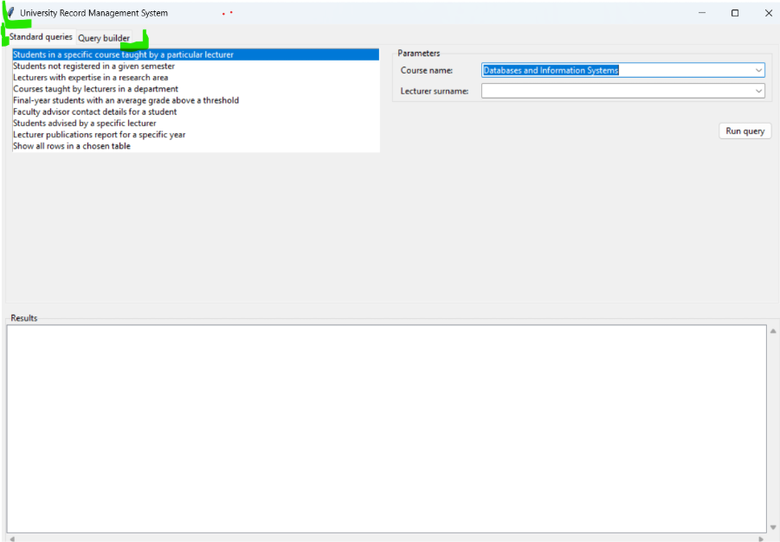
Figure 2. Query Interface (UAT-01)
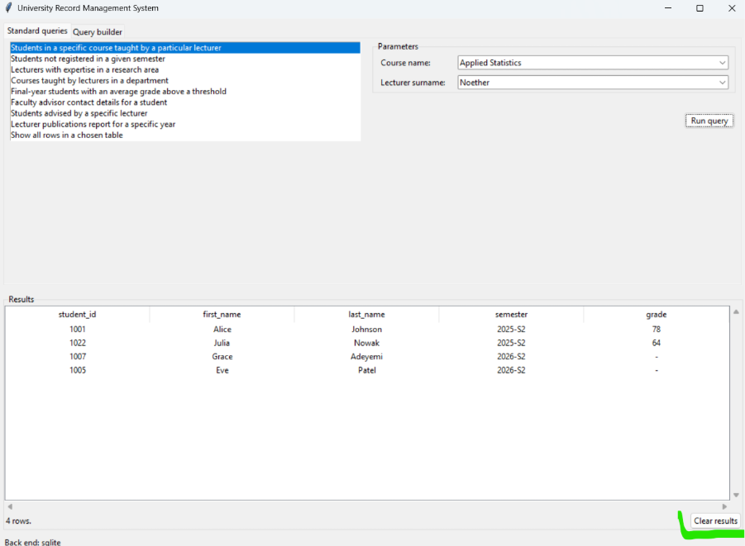
Figure 3. Query Interface-2 (UAT-01)
UAT-02: Find students enrolled in a Specific Course, taught by a specific lecturer
Discussion: The query returned expected student records. The results matched enrolment data, confirming the correct implementation of many-to-many relationship between Students, Courses, and Lecturers.
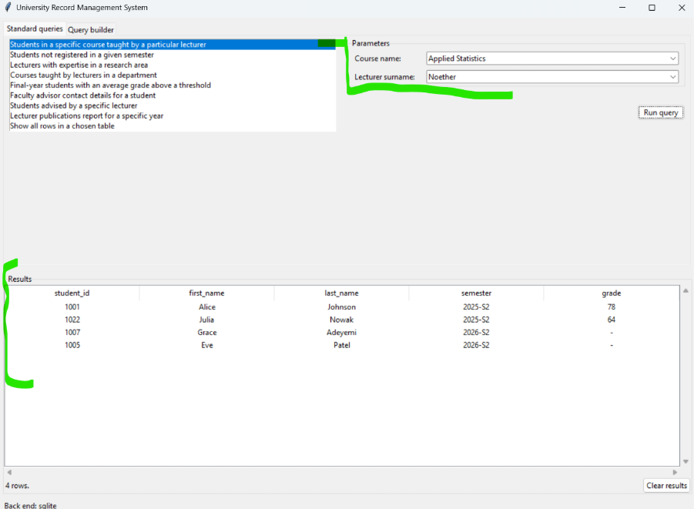
Figure 4. Student enrolled in a specific course, taught by a specific lecturer

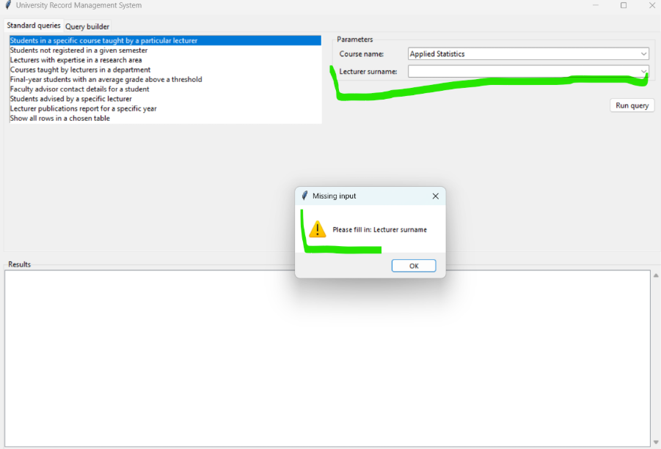
Figure 5. Safe fails when part of the query information is missing
UAT-03: List all students with an average grade above 70% who are in their final year of studies
Discussion: The query successfully calculated average grades and returned qualifying students, demonstrating that grade data is stored correctly and supports aggregate calculations.
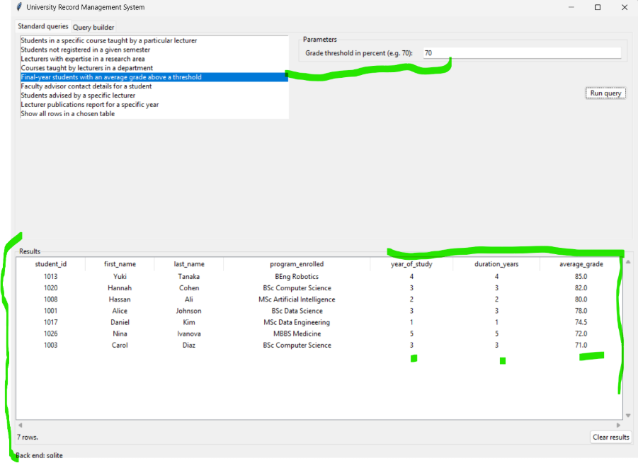
Figure 6. Students with average results above 70%

UAT-04: Identify students who haven't registered for any courses in the current semester
Discussion: The query correctly distinguished between enrolled and non-enrolled students. This confirms the integrity of enrolment records and relationship constraints within the database.
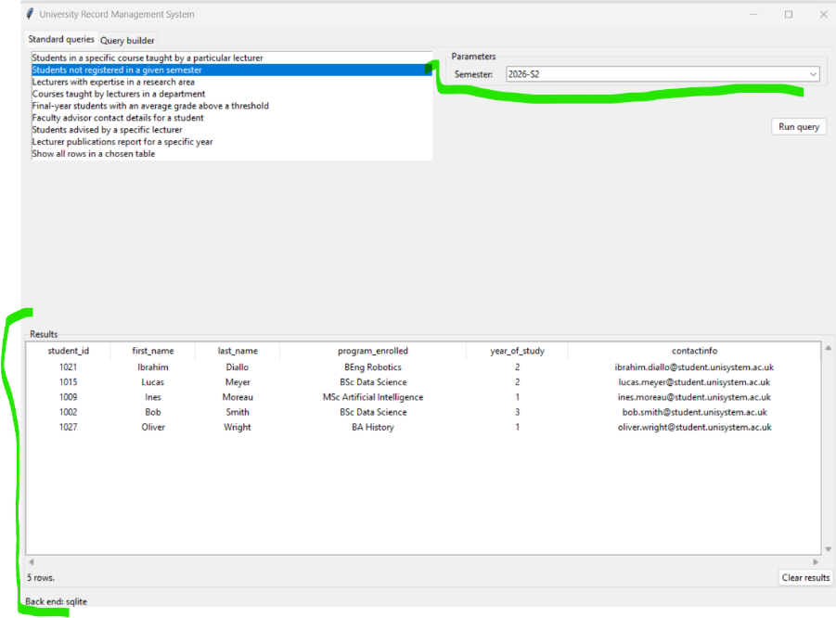
Figure 7. Students not registered for any course in 2026 semester S2

UAT-05: Retrieve the contact information for the faculty advisor of a specific student
Discussion: The system successfully returned advisor details for the selected student. This validates the one-to-many lecturer-student advisory relationship and confirms that advisor assignments are maintained correctly.
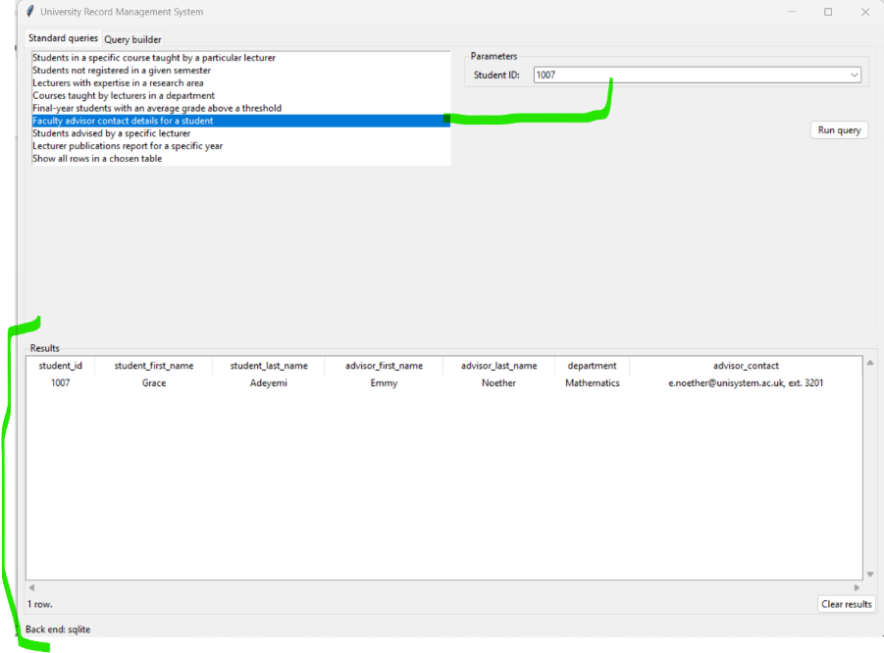
Figure 8. Faculty advisor information for student with ID: 1007

UAT-06: Search for Lecturers with Expertise in a Particular Research Area
Discussion: The query returned the expected lecturer records. This confirms that the expertise areas have been correctly normalised and linked to lecturer records.
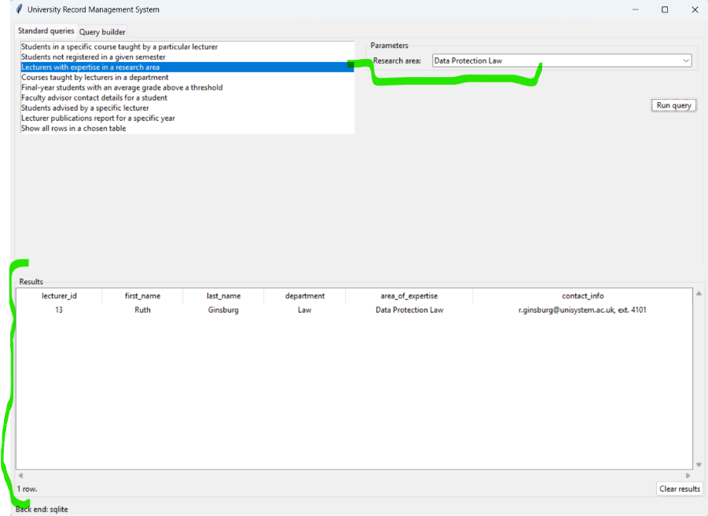
Figure 9. Lecturer search by expertise area

UAT-07: Query Builder
Discussion: The query builder allowed users to create and execute customised searches. This improves system flexibility by supporting information retrieval beyond the predefined queries.
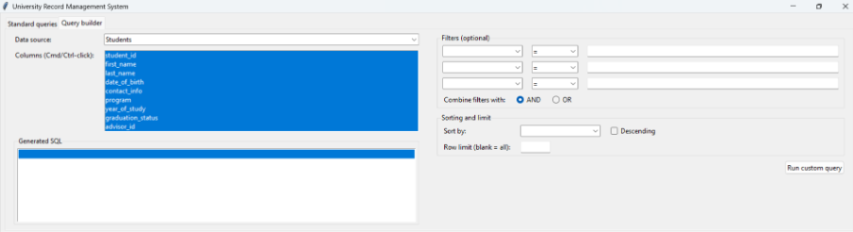
Figure 10. Query builder interface
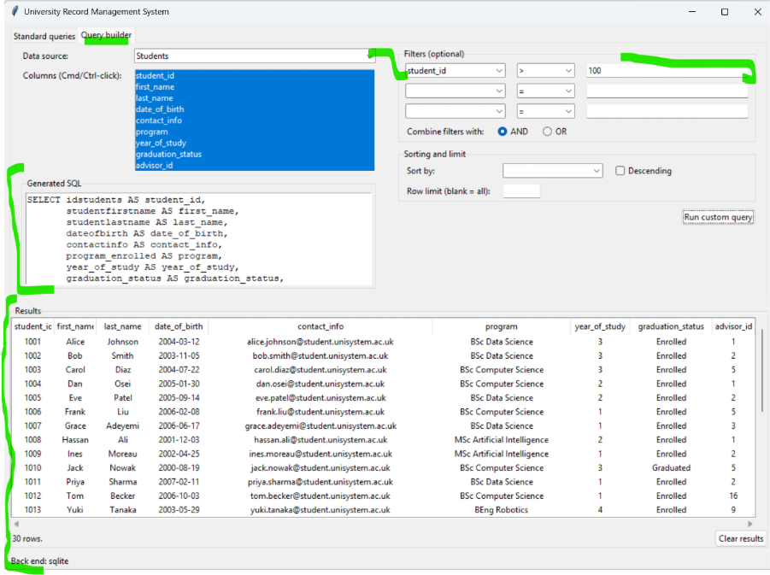
Figure 11. Custom query example

- CLI parity screenshots
To evidence that the same query engine drives both front ends, we captured the following CLI screenshots. Identical results across the two interfaces confirm that the catalogue-driven architecture holds.
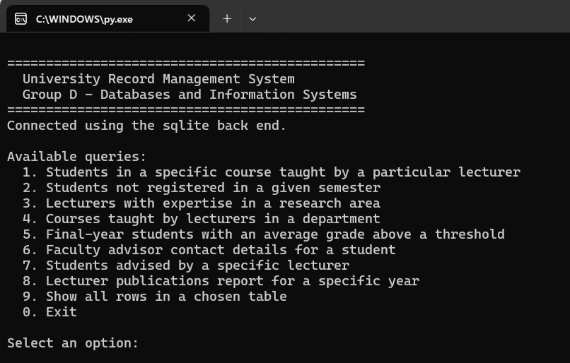
Figure 12. CLI – banner and numbered menu of nine queries

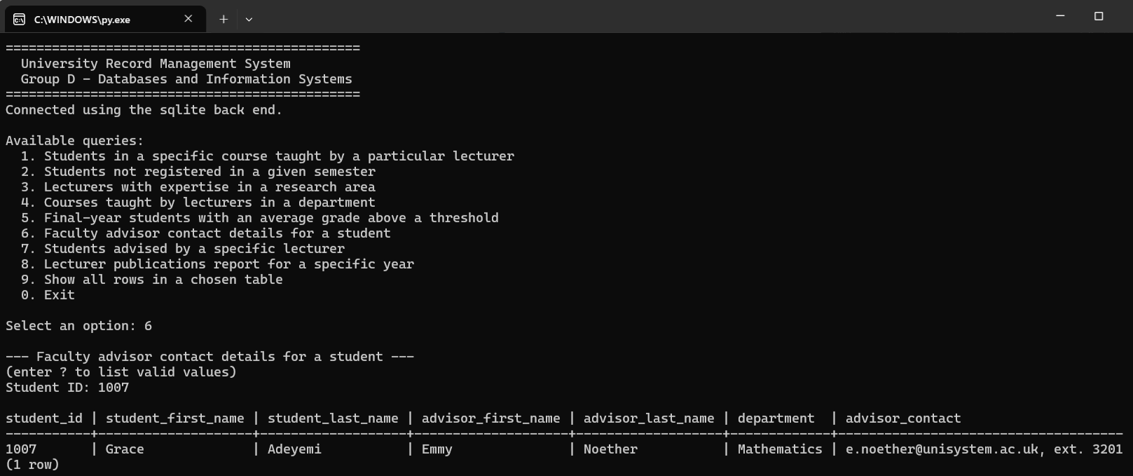
Figure 13. CLI – Query 6: advisor contact query (parity with Figure 8)
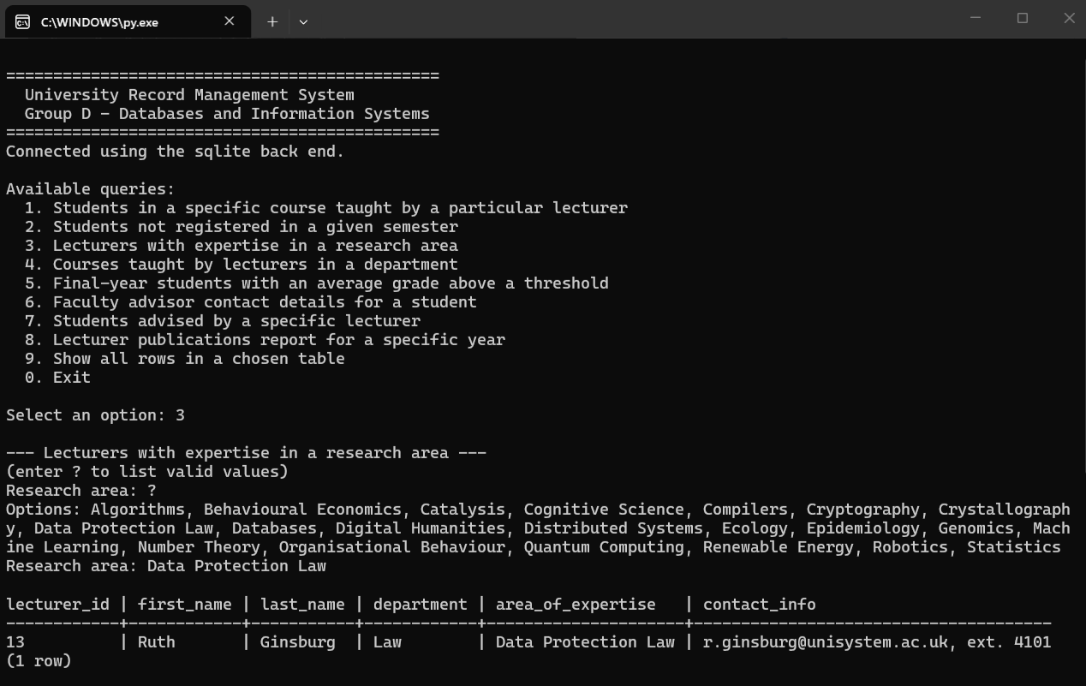
Figure 14. CLI – ‘?’ listing of enumerable parameter values (mirror of GUI dropdowns)

- Limitations and future improvements
No critical issues were identified during testing. Future enhancements could include role-based access controls and report functionality.

- UAT summary
All test cases were completed successfully and produced the expected results. Testing confirmed the system meets its functional requirements and is suitable for its intended purpose.

- Extended Critical Analysis, Extension Path and Retrospective

- Development narrative – MVP first
The theme running through our build was that each increment was shippable and independently verified, so no work depended on a large upstream change landing intact. This mirrors the minimum viable product discipline described by Ries (no date): building the smallest version of the system that permits validated learning, and iterating from there.
- Review and plan. Our Database Designer produced the initial MySQL Workbench schema. Our software Engineer’s review identified three fixes needed before the required queries could run: a student.advisor_id foreign key to lecturers (originally missing), numeric grades, and the department FK type mismatch.
- MVP – a walking skeleton. We built a CLI that runs the four queries the original schema could already answer against a self-seeding SQLite database. We chose SQLite deliberately as the iteration vehicle: no server, resettable by deleting one file.
- Full query set + dual back end. Once the fixes were agreed upon, we added MySQL support via the same DB-API interface.
- GUI. We built a Tkinter window exceeding the “simple interface” brief: standard queries plus a query builder that shows its generated SQL. We reused the engine unchanged – the payoff of layering
- Hardening. We merged our Designer’s normalisation (surrogate DepartmentID, unique department names, restored course.level) and adapted the application layer the same day, with the test suite as the safety net.
- UX iteration. We added live dropdowns for every enumerable parameter, then cascading filters – choosing a course narrows the lecturer dropdown to those who teach it. The dropdown is literally the same JOIN the query runs, i.e. our relational design surfaced as UX.

- Extension path – from MVP to production
Stage 1 – Shared departmental server. Point config.ini at a shared MySQL instance. Add a least-privilege database account (SELECT-only – the app never writes), and a course_lecturers assignment table so teaching no longer depends on enrolments existing.
Stage 2 – Multi-user web application. Replace Tkinter with a web frontend (e.g., Flask/FastAPI + HTML). Because our queries.py is a set of pure functions that return rows, it becomes the service layer of a REST API almost unchanged; the catalogue becomes the API’s endpoint definitions. Add authentication and role-based access; given the personal data held, this is required for GDPR compliance (European Parliament and Council of the European Union, 2016).
Stage 3 – Cloud deployment. Managed MySQL (e.g. AWS RDS), a containerised app (Docker), a CI pipeline running our existing unittest suite and flake8 on every push, plus automated backups and monitoring. The API is stateless, so it scales horizontally.
Stage 4 – Enhanced functionality. Write operations (enrolment as a transaction, grade entry with validation), dashboards and reporting, and full-text search over courses and publications. At that scale an ORM (SQLAlchemy) and a migration tool (Alembic) replace hand-written SQL and consolidated DDL – the point where the migration-script trade-off in B.5 reverses.
What survives every stage unchanged in our design: the schema, the query logic and the test suite. What gets replaced: the presentation layer. That asymmetry is our strongest single argument for the layered design.

- Extensibility priorities
- course_lecturers assignment table - removes the modelling flaw in Chapter 7; small schema change plus one JOIN change in two queries and the cascade providers.

- Live MySQL validation + CI - run our Designer's Workbench pass on schema.sql; add a GitHub Actions workflow running python -m unittest and flake8 on every push. Our suite is fast (~0.5 s) precisely so CI is trivial.
- Naming cleanup - contact_info (lecturers) vs contactinfo (students) survived our merge; unify while the codebase is small.
- Write operations - enrolment as a transaction (seat checks, prerequisite validation), grade entry with range constraints; introduces the first need for COMMIT/ROLLBACK handling in db.py.
- Authentication and roles - prerequisite for any multi-user deployment given the personal data we hold.
- The production ladder above - web front end over the unchanged engine, managed cloud database, ORM + migrations at the point where write-heavy complexity justifies them.

- Retrospective – what we would do differently
- Share schema changes as reviewed migrations from day one. Our engineer's fix list and our designer's normalisation solved the same flaw two different ways in parallel (name-keyed vs surrogate-keyed departments). A single reviewed change would have prevented the one integration incident of our project.
- Agree on naming conventions before writing DDL. The contact_info/contactinfo split is harmless but visible, and a five-minute convention would have prevented it.
- Stand up CI at the first commit, not after delivery. Every quality gate we used locally (tests, flake8) was CI-ready the whole time; automating it earlier would have protected the shared branches, not just our local checkout.

- What we would keep unchanged. Our walking-skeleton MVP, the zero-dependency rule, and testing against real schema and data from the first week — all three repeatedly converted risky changes (schema swap, 3× data growth) into same-day, verified work.

- Alternatives considered and rejected
Three further design choices deserve to be defended by naming what we did not do.
Tkinter over a web front end or PyQt. A web application is the natural production shape and PyQt looks more modern, but both introduce installation friction — a server or a licensed toolkit — that would have complicated marking and demonstration. We chose Tkinter because it ships inside the standard library, so our entire system runs from a single command. The cost we accepted is a dated visual style and a single-user ceiling; our layered architecture (Chapter 3) makes the front end the replaceable component if either constraint later matters.
A static schema whitelist over runtime introspection. Our query builder could have discovered tables and columns via PRAGMA table_info (SQLite) or information_schema (MySQL). Introspection never goes stale, but it is dialect-specific twice over and would expose every column with no curation. Our hand-written schema_meta.py whitelist is dialect-free, curated for user-facing names, and simultaneously acts as the identifier-injection defence described in Chapter 4. The cost — manual synchronisation with the schema — we catch with an integration test rather than leave it to discipline.
A consolidated CREATE script over an ALTER/migration script. When we normalised the schema mid-project we folded the changes directly into schema.sql rather than writing a migration. This was deliberate: no deployed database existed to migrate, and a single canonical schema file is easier to review than a chain of ALTER statements. At production scale this trade-off inverts, and a migration tool such as Alembic becomes the correct answer.

- Query Catalogue and SQL Evidence

- Mapping each query to the brief
Our nine implemented queries satisfy eight of the eleven suggested queries in the brief, plus a bonus "browse any table" for the query-builder demonstration. Our full SQL is in src/queries.py; the key clauses of each query are shown in C.3. All queries pass values through DB-API ? placeholders (Lemburg, 2001), which is the primary defence against SQL injection recommended by OWASP (no date).
Table 2 - Query Catalogue Mapped to the Brief
# | Query title | Parameters | SQL feature
1 | Students in a course by a lecturer | Course, Lecturer | 4-way JOIN on M:N junction
2 | Students not registered in a semester | Semester | NOT EXISTS correlated subquery
3 | Lecturers with expertise in a research area | Research area | LIKE substring match
4 | Courses taught in a department | Department | DISTINCT + 4-way JOIN
5 | Final-year students, avg grade > threshold | Threshold | AVG() + GROUP BY + HAVING
6 | Faculty advisor contact for a student | Student ID | 1:1 advisor JOIN
7 | Students advised by a lecturer | Lecturer surname | Inverse 1:N advisor JOIN
8 | Lecturer publications in a given year | Year | Equality filter on YEAR
9 | Browse any whitelisted table | Table name | Runtime SELECT * on curated whitelist

- Cascading dropdown providers
Two providers in queries.py implement cascading filtering. When the user selects a course, we narrow the lecturer dropdown to only those who teach that course. The dropdown query is literally the same JOIN that the main query runs — the relational structure of the database becomes the shape of the UX for free.
LECTURERS_FOR_COURSE_SQL:
SELECT DISTINCT l.lecturerslastname
FROM enrollments AS e
JOIN lecturers AS l ON l.LecturerID = e.lecturer_id
JOIN course AS c ON c.Course_code = e.course_code
WHERE LOWER(c.name) = LOWER(?)

- Compressed SQL of each query (key clauses only)
Full statements are in src/queries.py; below shows the JOIN and WHERE structure of each.
Q1 — Students in a course by a lecturer:
FROM enrollments e
JOIN students s ON s.idstudents = e.student_id
JOIN course c ON c.Course_code = e.course_code
JOIN lecturers l ON l.LecturerID = e.lecturer_id
WHERE LOWER(c.name) = LOWER(?)
AND LOWER(l.lecturerslastname) = LOWER(?)

Q2 — Students not registered in a semester:
FROM students s
WHERE s.graduation_status <> 'Graduated'
AND NOT EXISTS (
SELECT 1 FROM enrollments e
WHERE e.student_id = s.idstudents
AND e.semester = ?
)

Q3 — Lecturers by expertise:
FROM lecturer_expertise x
JOIN lecturers l ON l.LecturerID = x.LecturerID
JOIN departments d ON d.DepartmentID = l.departmentID
WHERE LOWER(x.area_of_expertise) LIKE LOWER(?)

Q4 — Courses in a department:
SELECT DISTINCT c.Course_code, c.name, l.first, l.last
FROM enrollments e
JOIN course c ON c.Course_code = e.course_code
JOIN lecturers l ON l.LecturerID = e.lecturer_id
JOIN departments d ON d.DepartmentID = l.departmentID
WHERE LOWER(d.DepartmentName) = LOWER(?)

Q5 — Final-year students, avg > threshold:
FROM students s
JOIN programs p ON p.name = s.program_enrolled
JOIN enrollments e ON e.student_id = s.idstudents
WHERE s.year_of_study >= p.duration_years
AND s.graduation_status <> 'Graduated'
AND e.grade IS NOT NULL
GROUP BY s.idstudents, ...
HAVING AVG(e.grade) > ?

Q6 — Advisor contact:
FROM students s
JOIN lecturers l ON l.LecturerID = s.advisor_id
JOIN departments d ON d.DepartmentID = l.departmentID
WHERE s.idstudents = ?

Q7 — Advisees of a lecturer:
FROM students s
JOIN lecturers l ON l.LecturerID = s.advisor_id
WHERE LOWER(l.lecturerslastname) = LOWER(?)

Q8 — Publications in a year:
FROM lecturer_publications p
JOIN lecturers l ON l.LecturerID = p.LecturerID
JOIN departments d ON d.DepartmentID = l.departmentID
WHERE p.publication_year = ?

Q9 — Browse a whitelisted table:
SELECT <columns from schema_meta whitelist>
FROM <table or joined view from schema_meta whitelist>
Every query above uses DB-API ? placeholders — never string formatting — and every identifier used by Q9 comes from the whitelist described in Chapter 4.

